**Project Update**

**Checkmate**

# **Purpose**

The project is at an estimated 90% completion based on its current state in regards to the initial proposal, posed requirements, and design documentation.

# Initial Proposal Deviations

At this current moment, there has not been any major deviations from the initial project proposal. We have been able to implement all of the minimum viable product requirements and time permitted requirements. Additionally, we managed to complete some of the wishlist features as well. However, there is one minor deviation from the initial proposal. Originally, we decided on using the Python Chess Library but after much consideration, we ultimately went with the React Chessboard Library for the visuals of the 2D chessboard.

At this point in time, we have no plans to deviate from the initial requirements. Should time permit, we intend to cover all base stated requirements. Otherwise, only minor requirements should be affected.

We have completed the Main Menu page, the Game Mode selection page, the entirety of Classical and Bullet Mate pages and functionality, the Help page, the Custom Puzzle create page, and styling for a majority of the remaining pages. Some pages, such as Leaderboard, have information that will need to be loaded into it, in order to consider the page complete.

There are a few features that are yet to be implemented. A major feature is the login using Google Firebase, which is currently in backend development. The login will allow for users to either register for a new account or login with a preexisting one. The frontend of the login page will also need to be styled according to the design documentation.

Once the login is created and functional, the user’s most recent scores can be loaded onto the settings page. The legal dots indicator, also located on the settings page, needs to be functional across the entire website, which we predict will be done using local storage. In addition, the login will be responsible for allowing the user to create their own username. This username will be used for the leaderboard and the create puzzles.

The leaderboard page itself must be populated with accurate scores. As of now, there are containers for either type of score to display, but no scores are displayed. As for custom puzzles, the Play custom puzzles page is not styled according to the design documentation. A rating system must be shown on the list as well. Styling must be done for the following page when a user selects a puzzle from the list to play.

# Design Deviations

As far as design changes, we have decided to include two small images on the Game Mode selection page in order to add to the user experience and fill in empty space. There are deviations from the original design on both the Classical Mate and Bullet Mate layout, as some information displayed has been moved to either side of the board in order to flow more intuitively. All of this information is held in one of two blocks on either side, rather than each piece of information having its own designated block. This design choice was simply due to aesthetic purposes. There is also the new addition of a start button on the left-side container in both modes, which was needed in order for the backend to be notified when to generate a new puzzle. The title of the mode itself has been moved from the top to the left-side container for both modes to ensure that the gameboard is given plenty of room on a user’s screen. Popups now have a subtitle as well, explaining more to the user such as, “You have lost all lives.”

While not specified in the design documentation, the navigation bar now has designated links consistent across most pages, with the title, “Checkmate” on the far left to give the website a modern look. Also not specified in the design documentation but styled since its creation is the background of the entire website, as well as the color palette chosen for all elements in Checkmate.

The “Help & Tutorial” page is now titled “Help And About Us”. In addition, the subtitle “About” has changed to “About Us,” and the subtitle “Pieces” has changed to “Piece movement and capturing”. All of these changes were for better clarification. In addition, the Leaderboard page has the mode name enclosed in the leaderboard itself, rather than outside as the design documentation showed, for stylistic purposes. On the Settings page, the subtitle “Scores” has changed to “Recent Scores” for clarification that this is not an exhaustive list of all scores a user has achieved. The time is also included in a user’s recent scores so that Bullet Mode game times are shown. In the options box, the option of having dots or not has gone from the design document’s simple radio button with text, to radio button pictures of what dot indicators look like when toggled vs. not. A user is presented with the default toggle of dots on, as indicated by a red border, but they may choose the alternative by selecting the radio button beside the default. This choice was to make the dots indicator option easier for users to understand.

As for the Custom Puzzles selection page, we have also opted to include two small images under the Create and Play selection titles in order to add to the user experience and fill in empty space. Now, the Create button also does not redirect to the Login UI, simply due to us running short on time and still working on Firebase Authentication. On the Create page, the pieces are above and below the board, rather than in a left-side container. This is because the backend programming did not allow for the movement of these piece’s starting positions. In addition, there is now a tutorial button, which has various popups and piece movements on the chessboard in order to guide the user on creating their own puzzle. There is no count of the number of pieces, either white or black, because we felt that it was unnecessary to the puzzle creation process. To ensure we have a puzzle where the king is in check, a popup will also notify users in case they attempt to submit this invalid puzzle state. There is now a confirm position, reset position, and back button on the left side, which made the most sense for the puzzle creation interface. The Confirmation page has near identical changes, except the “Confirm position” button now says “Confirm solution”. Lastly, the Play custom puzzles page and the login do not have enough styling complete in order for us to identify deviations yet.

# Obstacles

Currently, the biggest issue that we are facing is user authentication. We managed to get the Google login popup to show up for the user, however, now we are trying to allow the user to create their own username. However, we only want to ask the user once for their username and store that into the database along with their unique id that is given to each user when signing in through Google. We would consider this to have a minor impact on the success of the project because logging in is not crucial to the overall success of using our web application. Additionally, another roadblock that we are currently facing is the settings. Until we are able to store the username and the unique id, we are unable to store the user’s settings at this time. This is also considered to have a minor impact on the success of the project because it does not affect a user’s ability to interact with our application.

# **Design Diagrams**

Pictured below is our up-to-date component diagram. There are more state variables and methods that were not accounted for in the original design. Additionally, in the original component diagram, the Classical UI and Bullet UI were wrapped into one component originally called “ChessUI”. However, at the beginning of development, there was a major road bump in separating the functionality of Classical Mate and Bullet Mate in the same component. Therefore, these two components were given their own space. Recently, we discovered a way that would allow us to include both functionality within the same component, however, it is too far into the project to refactor at this current moment.

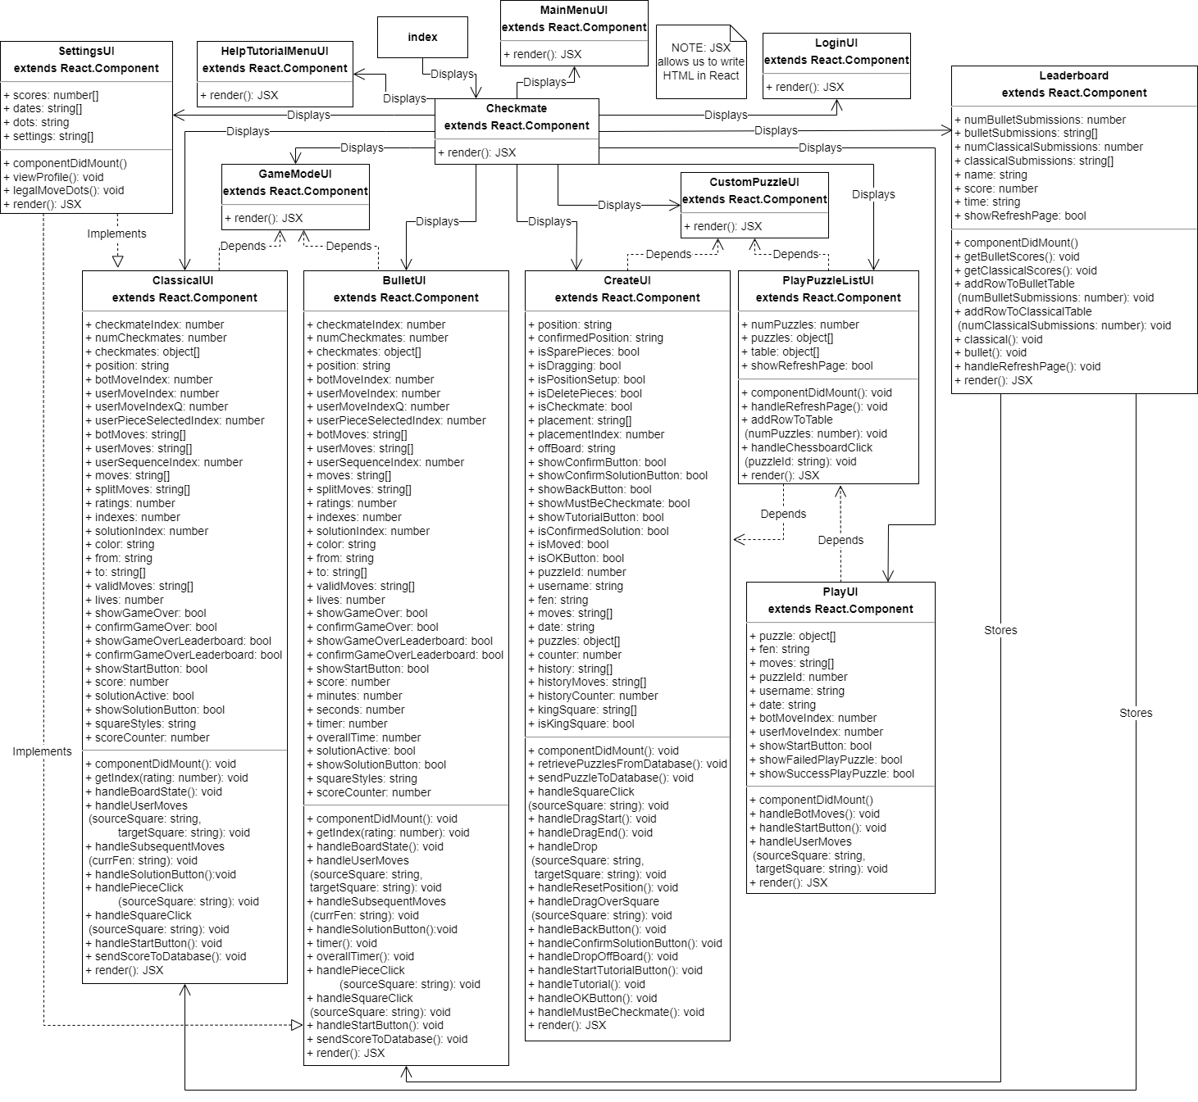

Figure 1. Component Diagram

Pictured below is our up-to-date ER Diagram. The only change that needed to be updated was the custom-puzzles table. We are now storing the date of each puzzle created in order to display this inside of the Play Puzzle List.

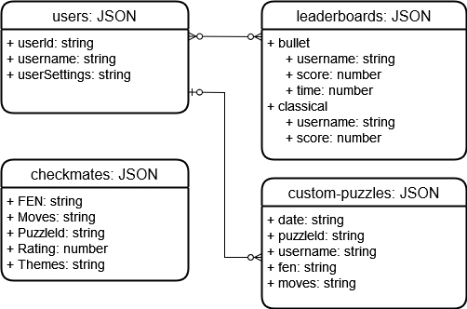

Figure 2. ER Diagram